The London Tube
The first subway was London's Metropolitan Railway in 1863. It was not very long (about
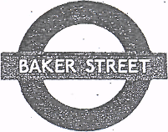
6.5 km/4 miles), and it linked Paddington station to Farringdon Street in thè City. It took
passengers into thè centre of London.
The first tunnels were not deep. To dig.the deep tunnels later (about 1890), thè
engineer J.H. Greathead invented a System to keep thè soft clay from falling onto thè workers. It was a tube-shaped iron shield that advanced as .thè workers made progress dìgging thè tunnels. This is why thè Londoners cali their underground thè "Tube".
Today, many cities in thè world have underground systems; for example, Paris, Washington D.C., Rome, and Moscow. But thè underground in London is one of thè largest systems in thè world. There are more than 270 stations on about 15 tube lines. Ali thè stations have a familiar round red, white and blue sìgn outside, and each line is a different colour on thè underground maps. The .tube runs every day except Christmas Day from about 5.30 am to about 12 o'cìock at night. Travelling by tube is a very fast, cheap and convenient way to get around London.
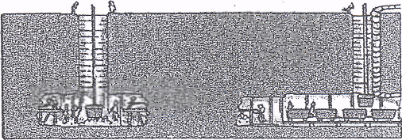
READING Read thè passage again, and mark these statements Rìghtor Wrong. If thè information is not given in thè passage, mark Doesn't say.

- J. H. Greathead built thè first subway in London.
- "Tube" is thè Londoners' name for their underground.
- The first subway in London was a long complicated System of tunnels,
- It took.four years to build thè first underground railway in London.
- The name "Tube" comes from a kind of protection used during
thè construction of thè tunnels.
- There are not many underground systems in thè world today.
7. Besides London, no other English city has an underground System. .
8= London's systern of underground railways is not very big.
- The underground stations in London are not marked very clearly.
- The tube is closed on December 25th.
Righi Wrong Doesn't say
n n n
d. n n n . n a non
n n n
n
a
a a
n
a
n
n
a

READING Read thè film review, and answer these questiona.
- Who directed thè film?
- What is thè name of thè film?
- What ìs it about, and who are thè main characters?
- Where do Vianne Rocher and her daughter decide to Uve?
- What kìnd of a shop does Vianne open there?
- What effect/s do/does this have on thè people who Uve there?
- What is Lent?
- What are, according to thè reviewer, thè film's positive qualities?
- Why does thè reviewer think that thè film is not completely authentic?
- What adjectives/expressions does thè reviewer use to describe thè photography thè characters and thè
director's abilities?

